LAB PROGRAM – 6

ORDER DATABASE:

TABLES:

SALESMAN

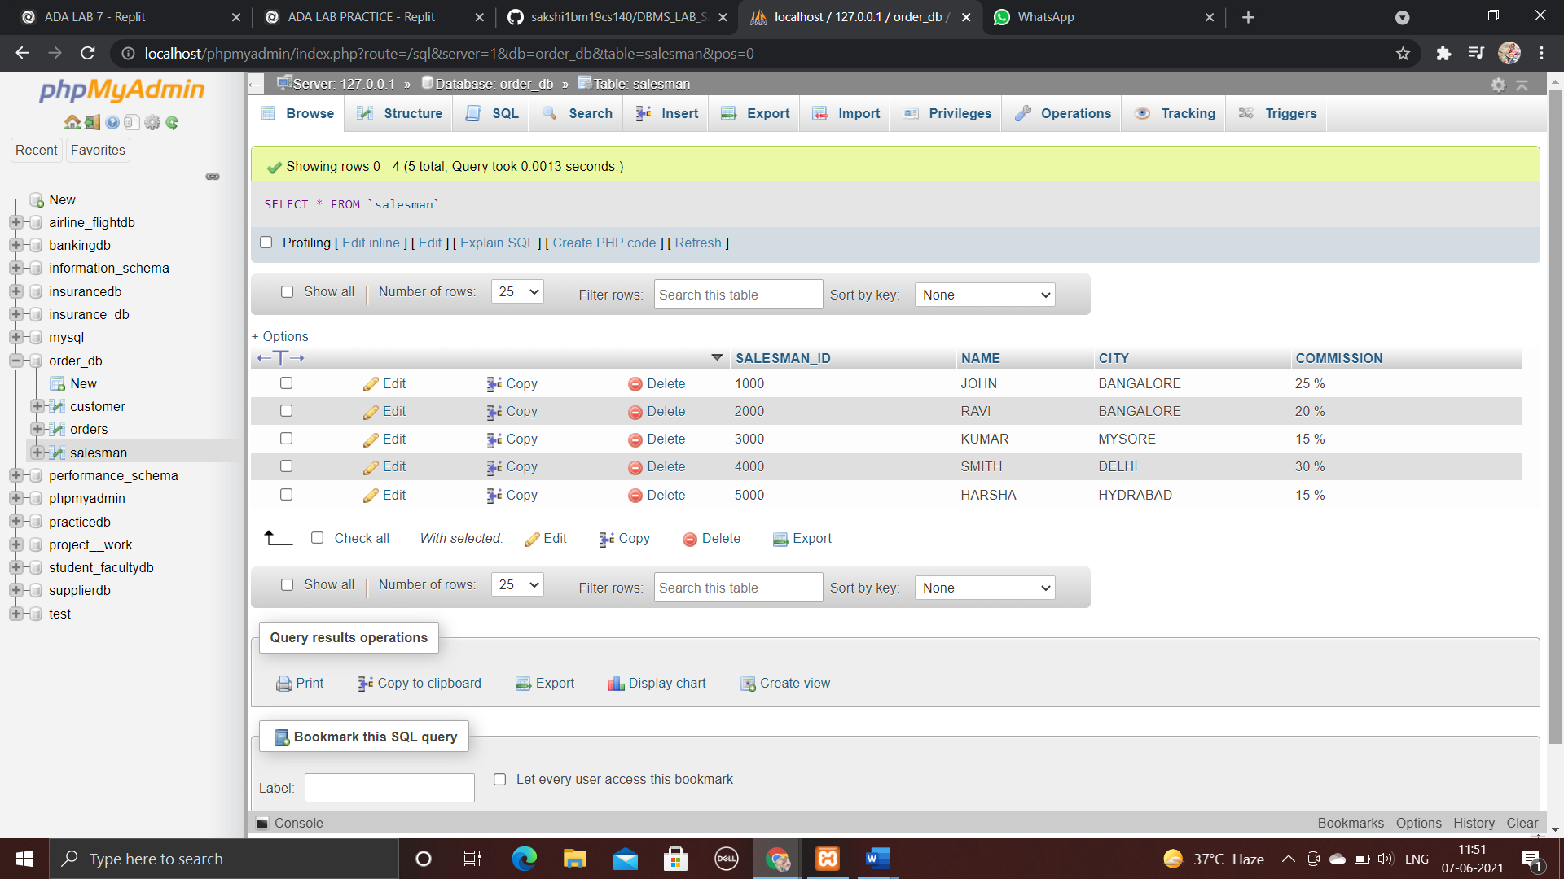

CUSTOMERS

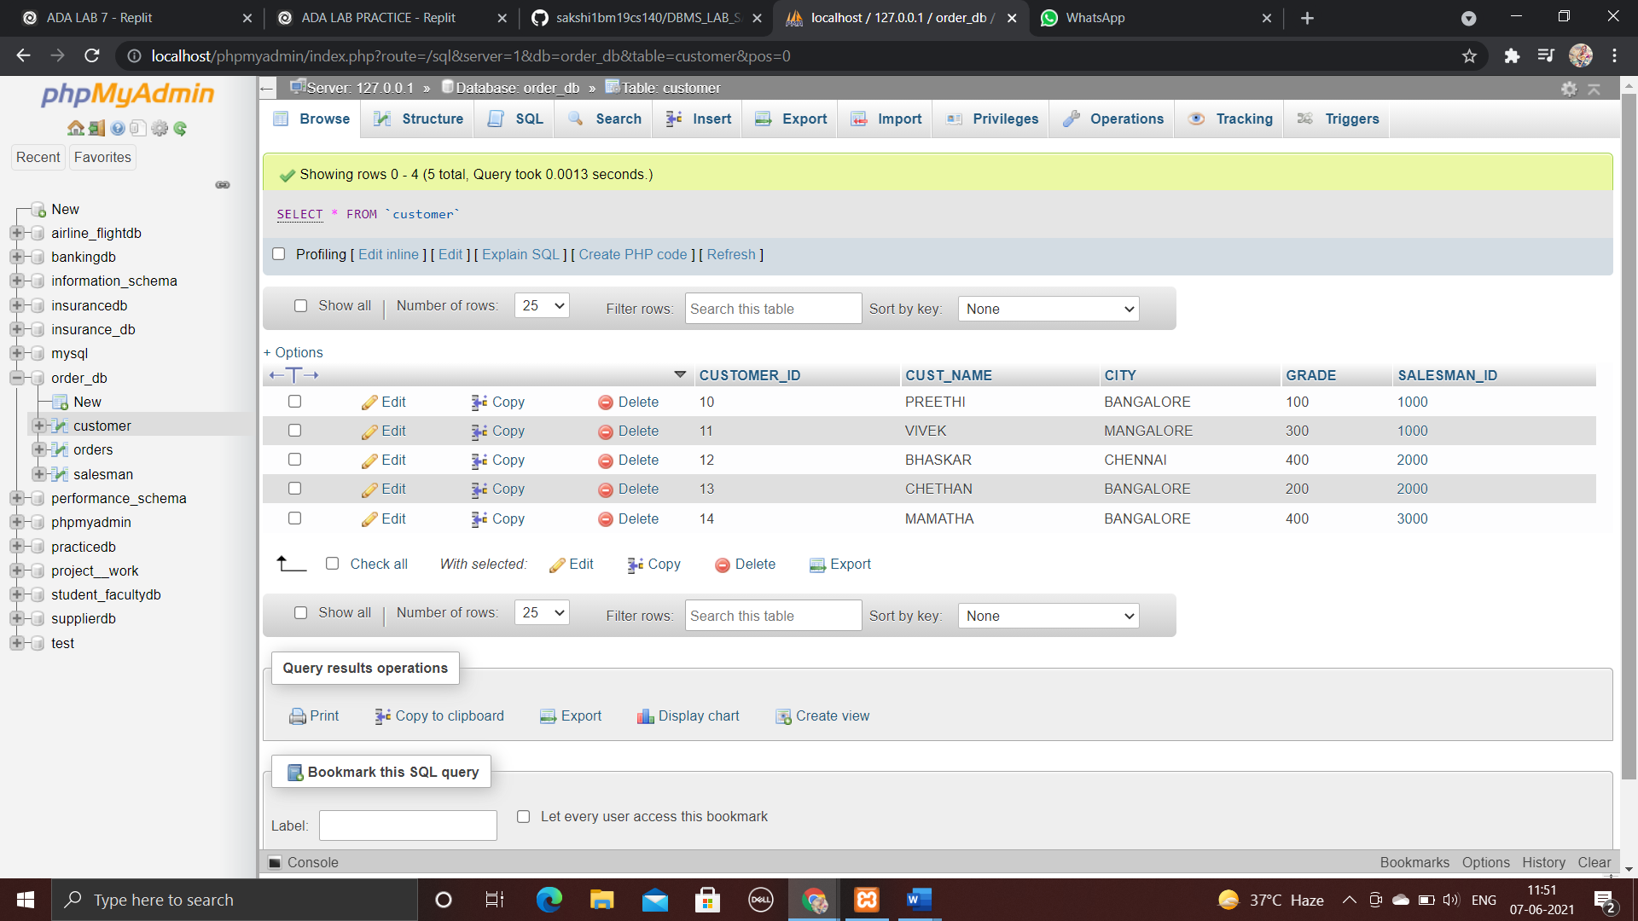

ORDERS

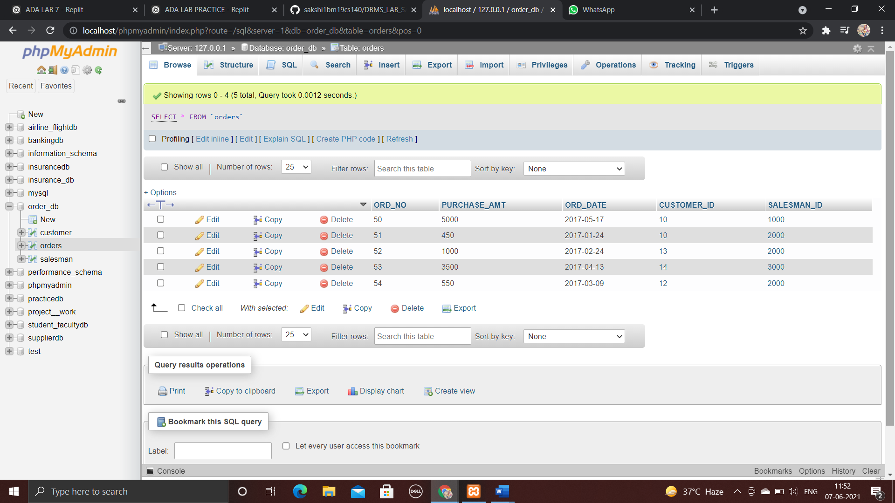

**Count the customers with grades above Bangalore’s average.**

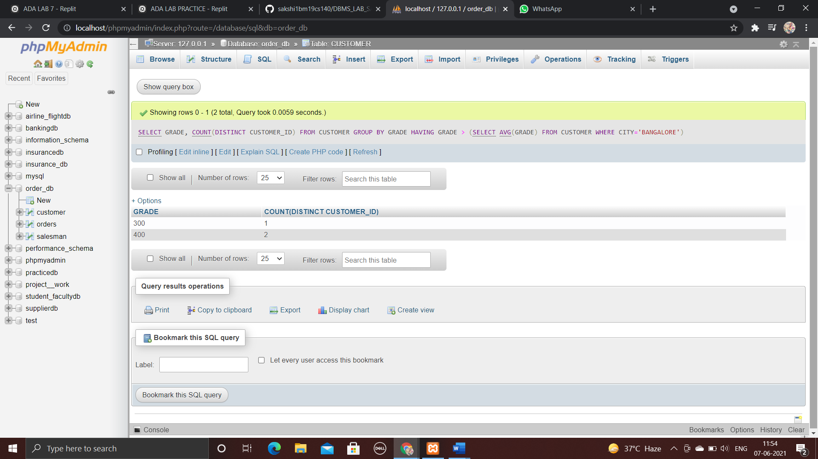

**Find the name and numbers of all salesmen who had more than one customer.**

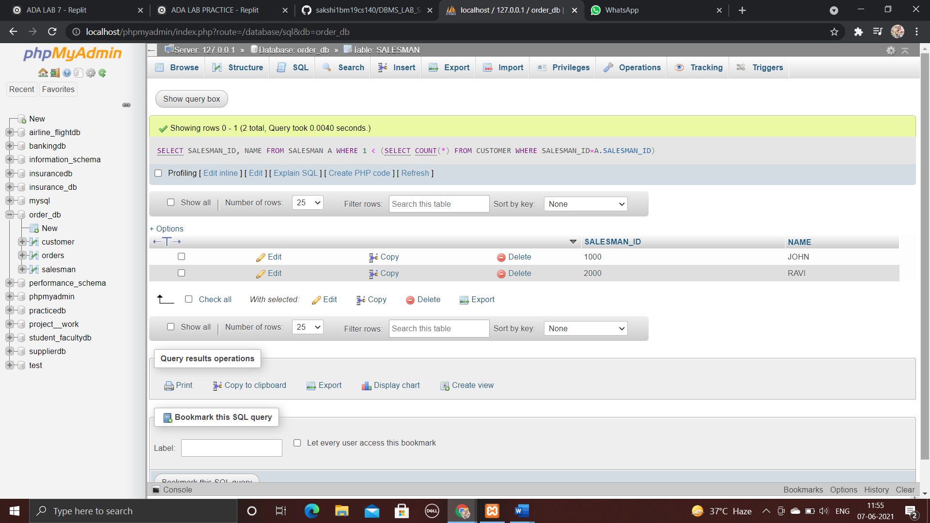

**List all salesmen and indicate those who have and don’t have customers in their cities (Use UNION operation.)**

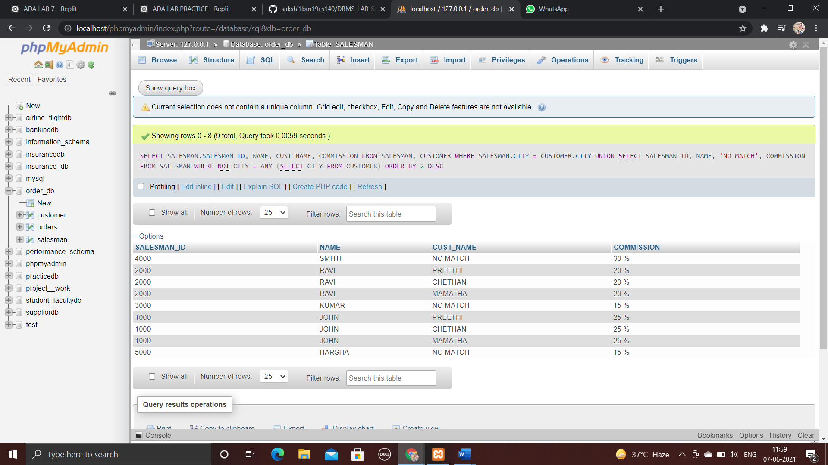

**Create a view that finds the salesman who has the customer with the highest order of a day.**

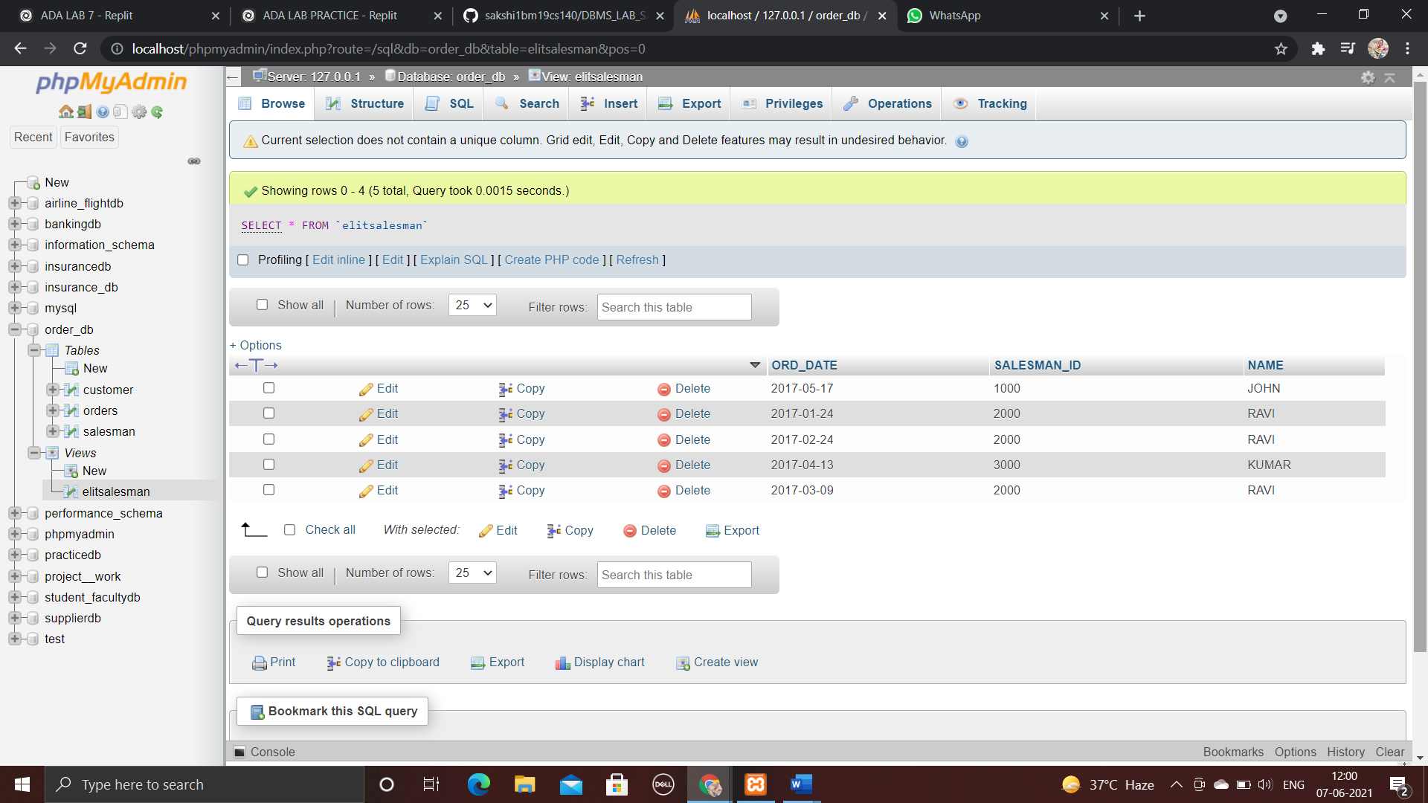

**Demonstrate the DELETE operation by removing salesman with id 1000. All his orders must also be deleted.**

